10. Recommendation

Recommendation — PROCEED (conditional on diligence and financing execution)
We recommend Sun Pharma proceed with the acquisition of Organon at $14.00/share. The price is fair-to-cheap (base-case standalone value ~$16.5/share, a ~15–20% margin of safety), the transaction is materially EPS accretive (~+60% Year 1), and it delivers scale, a women’s-health franchise, a top-10 biosimilars platform, and entry to China/Korea. The recommendation is conditional: the deal must be underwritten on Organon’s free-cash-flow durability and on terming out the bridge at a manageable cost — not on the headline EPS accretion, which is leverage-driven.

10.1 Deal attractiveness
- Price. ~6.2x EV/EBITDA, ~1.9x revenue — low end of comps, below precedents, ~15–20% under base-case DCF.
- Accretion. ~+60% Year 1 EPS, ~+75% by Year 3; no shares issued.
- Strategic fit. Top-25 global pharma; three platforms (innovative, established, biosimilars); China (~$800m) and Korea entry; Sun’s low-cost manufacturing applied to Organon’s portfolio.
- Balance-sheet capacity. Net cash funds a levered acquisition landing at ~2.3x, deleveraging on strong combined FCF.

10.2 Expected value creation
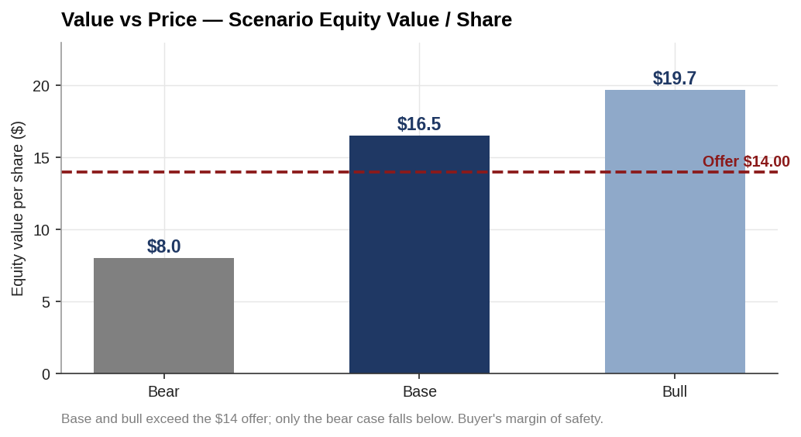
Value vs price — scenario equity value per share
Base and bull cases sit above the $14 offer; only the bear case falls below. Value creation comes from three sources: (1) buying ~$1.9bn EBITDA below intrinsic value; (2) >$350m of cost synergies; (3) redeploying Organon’s FCF to deleverage and lower the combined cost of capital. The EPS accretion is a by-product of the all-cash structure, not the value driver — the value driver is the discount to intrinsic worth plus synergies.

10.3 Key assumptions underpinning the call
Assumption | Base | Why it matters
Organon revenue trajectory | ~flat | Binding variable; decline vs growth swings value most
EBITDA margin | ~30% | Holds combined FCF
Cost synergies | >$350m (2–4 yrs) | ~5% of combined revenue; credible
New debt cost | ~6.0% blended | Bridge take-out pricing drives returns
Net leverage at close | ~2.3x | Deleverages over 4–5 yrs on FCF
WACC / exit multiple | 9.0% / 6.0x | Standalone DCF anchor

10.4 Major risks to the recommendation
Concentrated, not diffuse (Ch.9): established-brands decline, refinancing the ~$9.5bn bridge, the Nexplanon sales-practice probe, and biosimilar price erosion. The mitigants — low entry multiple, high cash conversion, committed bridge, and contractual protection on Nexplanon — are adequate but not abundant.

10.5 Alternative scenarios
- Bull (~$19.7/sh): revenue +1–1.5%/yr, margin 31%, synergies at/above $350m, orderly bridge take-out → strong value creation and rapid deleveraging.
- Base (~$16.5/sh): revenue ~flat, synergies on schedule, ~2.3x deleveraging over 4–5 yrs → the recommended case; ~15–20% margin of safety.
- Bear (~$8/sh): established-brands −4%/yr, Nexplanon-driven Women’s Health hit, higher refinancing cost → value below the offer; the case diligence must rule out.

10.6 Final verdict
Proceed. Sun is paying a low multiple for scale, a women’s-health franchise and a biosimilars platform, in a structure that is strongly EPS accretive and self-deleveraging on Organon’s cash flow. The margin of safety is real but not large, and the risk is concentrated in two variables — established-brands decline and bridge refinancing. Conditioned on disciplined diligence (especially the Nexplanon revenue base) and on securing the permanent financing at a manageable spread, the transaction creates value for Sun and is a fair outcome for Organon shareholders given the company’s standalone leverage and decline.

Assumptions & sources
- Scenario per-share values from the Ch.7 DCF (bull $19.7, base $16.5, bear ~$8.0); offer $14.00.
- Accretion (~+60% Yr1) from the Ch.8 merger model.
- Synergy, leverage and financing figures are company-disclosed where noted (Ch.4–5); all valuation inputs are analyst assumptions, flagged in their chapters.
Sources: synthesis of Chapters 1–9; company disclosures. Full map in 05_Data/DATA_SOURCES.docx.

